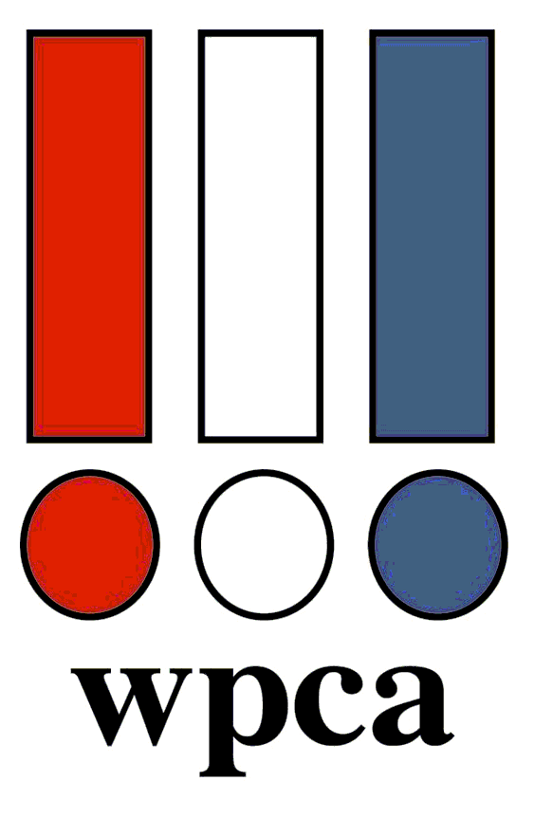 WPCA August 26th, 2025
Golf Outing – Meadowbrook Country Club

Please join us August 26th 2024 at Meadowbrook Country Club in Racine, WI. Meadowbrook Country Club is located in southeastern Wisconsin, on the edges of the city of Racine, just a short drive from Milwaukee, Kenosha and northeastern Illinois. The jewel of Meadowbrook is an 18 hole par 71 golf course. The course that is both beautiful and challenging will test the skills of even the most experienced golfer. The golf course has a creek and two ponds that come into play on eight holes. Most of the fairways are wide and tree lined. The terrain is predominantly flat. Sand bunkers come into play on almost every hole throughout the design. The greens are medium-sized, sloped and fast. Meadowbrook has hosted five Wisconsin state opens and numerous other prestigious events over the years. Whatever your handicap, MCC offers an enjoyable challenge to all who play it.

Reserve your spot today!!! Directions to the course are shown below.

Meadowbrook
Date : Tuesday, August 26th, 2025
Time : Shotgun Start at 12:30 PM
Cost : $150.00 per golfer.
The outing package includes: 18 holes of golf on the Meadowbrook Country Club with a cart, range balls, lunch, and dinner. Payment must accompany your reservation!

For Reservations: Please send your checks with completed registration form to the address below:

Andrew Wensing
1245 Chapman Dr,
Waukesha, WI 53186
Phone: (262) 939-5098
email: andrew.wensing@holcim.com

This event is possible through your generous hole sponsorships and donations! Without it, we could not provide the door prizes, team and individual awards. Thank you for your support!

HOLE SPONSORSHIP: $100.00 per hole
Donations are also needed for the Door prizes to be raffled off.
Please make checks payable to the Wisconsin Paint and Coatings Association.
Top of Form

WPCA Meadowbrook Golf Outing Directions
https://goo.gl/maps/PntfcrEpFD5vKT2T7

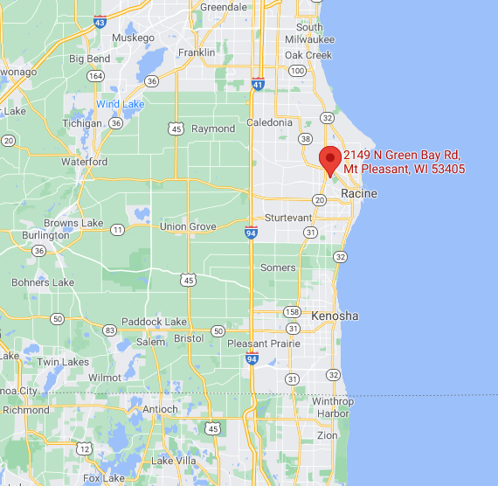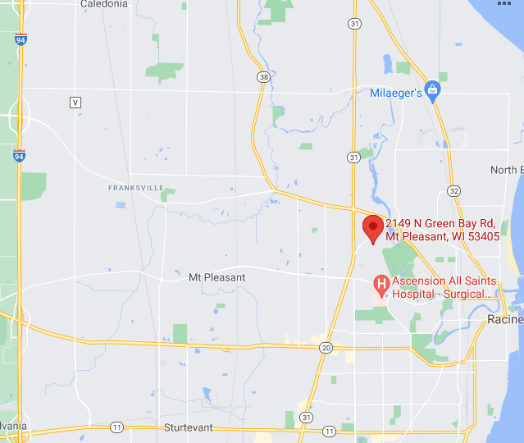

Meadowbrook Country Club * 2149 N Green Bay Rd Racine, WI 53405
(262) 898-9900 * www.meadowbrookracine.com
Bottom of Form

WPCA Reservation/Sign Up Form

WPCA Tuesday, August 26th 2025 Golf Outing – Meadowbrook Country Club
(Payment must accompany Reservation)

(Please Print or Type)

Name

Company Name

Address

City, State Zip

Foursome #1: Foursome #2

Golfer 1 ______ _____________ Golfer 1:

Golfer 2 Golfer 2:

Golfer 3: Golfer 3:

Golfer 4: Golfer 4:

Total Number of Golfers: @ $150.00 per golfer = $
(Make checks payable to WPCA)
(All checks must be received two weeks prior)

Mail to: Andrew Wensing
1245 Chapman Dr,
Waukesha, WI 53186

Hole Sponsor Donation: ____________ @ $100.00 per hole = $ ______
Donation, Other: $
Total Enclosed Check: $ ______

